**TMR0 as a counter**

*Lab #5*

**Phillip May,** 1639294

**ABSTRACT**

*In this lab I programmed to the PIC16F887 to use tmr0 as a hardware counter.*

Experiment Performed on **18 October 2017**

Report Submitted on **25 October 2017**



Department of Computer

Engineering Technology

**INTRODUCTION TO MICROPROCESSORS (247-302)**

*Day Yann Fong*

Table of Contents

Introduction 3

Procedure 3

Results and Discussion 3

Conclusion 5

References 5

# Introduction

In this lab I learned about switch bouncing and how to use tmr0 as an 8 bit counter. I also practised programming the PIC16F887 and using the debugger to solve problems.

# Equipement

• PIC16F887

• Pickit3

• 2 100nF capacitors

• 4 LED

• 4 270ohm resistors

•10Kohm resistor

•1 push button

•Connecting wires

# Procedure

The procedure is provided in the lab instructions.

# Results and Discussion

Step 2:

For the push button take the one that was previously being used on PORTB and wire it up to TMR0IN on port 6.

a)

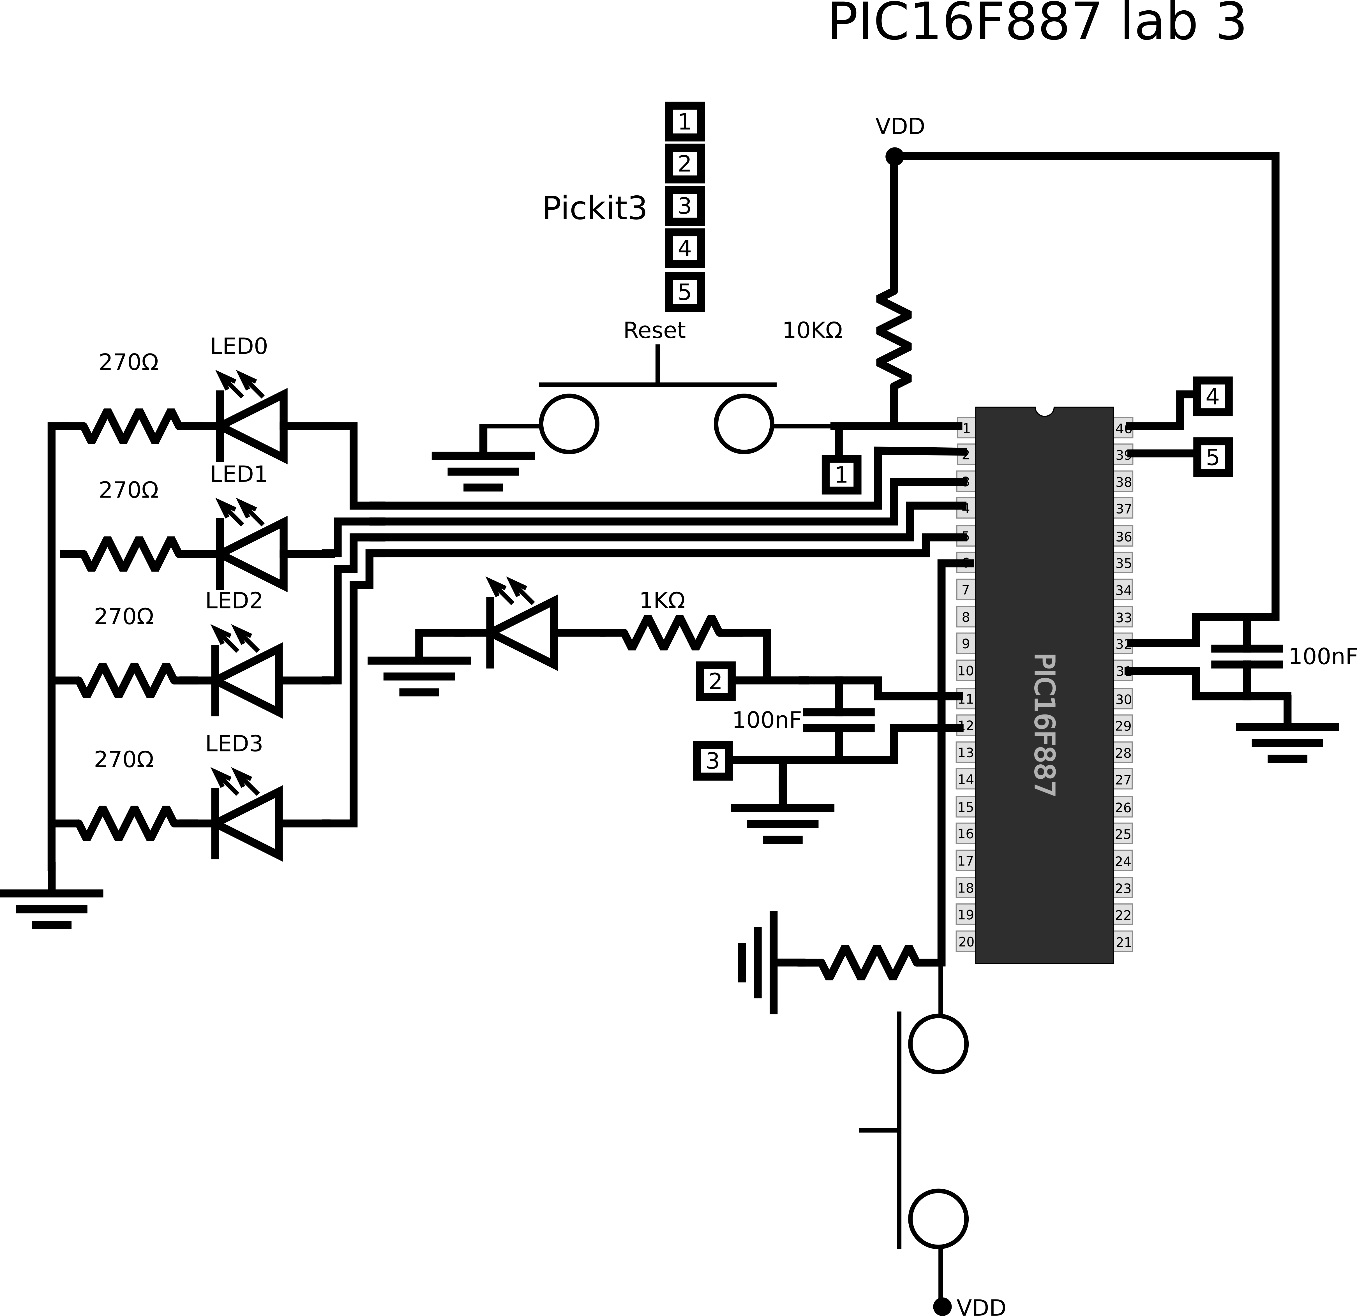

b)

Code included with lab report, of particular note is that PORTA4 needs to be an input otherwise TMR0 will not be able to increment past 10h.

Step 3:

1. Does the counter (as indicated by 4 LEDs) always operate expected? If no, why?

No it does not.

1. If your answer is no in part (a), what could be the possible solution(s) to resolve problem?

No it does not, the reason for that being an electrical property of buttons called “bouncing”. In theory when you press a button it connects the two sides and disconnects them when not pressed. In reality when a button is pressed (or released) the contacts touch don’t make a clean connection a few microseconds. This can sometimes trigger a things more than once. The two solutions would be hardware and software de-bouncing to remove this effect. Given that we are using tmr0 as a counter the only option is hardware de-bouncing. It’s possible to make a circuit to remove the bouncing effect however I did not do that as I did not have the materials to do so.

A screenshot of bouncing.

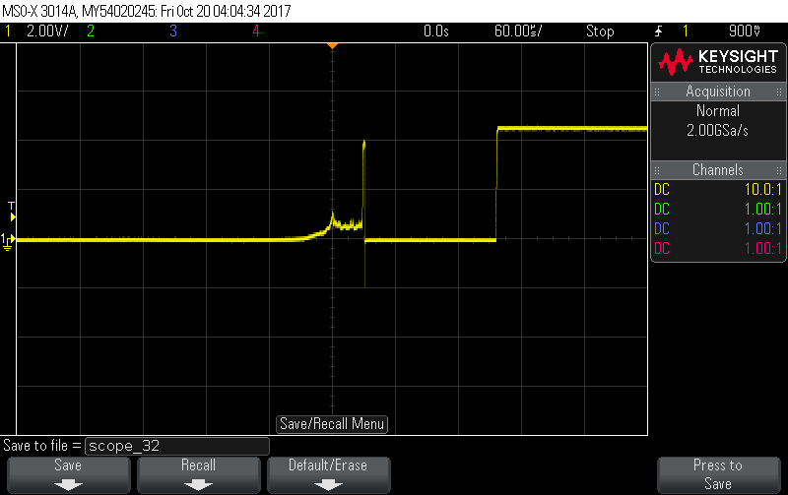

# Conclusion

In this lab I learn how to use the PIC16F887’s tmr0 as a 4 bit synchronous counter that outputs on PORTA. I also built on what I learned in previous labs such as how to use debugger and subroutines. The only significant issue I came across was the use of PORTA4 which I discussed in results.

# References

|  |  |
| --- | --- |
| [1] | Microchip Technology Inc., "MPASM Assembler, MPLINK Object Linker, MPLIB Object Librarian User's Guide," Microchip Technology Inc., 2013. [Online]. Available: http://ww1.microchip.com/downloads/en/DeviceDoc/33014L.pdf. [Accessed 20 9 2017]. |